EXPLORATORY DATA ANALYSIS (EDA) REPORT
Movie Analytics and Box Office Revenue Prediction System
Dataset: enhanced_box_office_data (2000–2024)
Prepared: 14 October 2026
Purpose: examine the structure, quality, distributions, relationships, and limitations of the movie dataset before applying search algorithms, graph-based analysis, recommendation logic, and Elastic Net regression.

1. Executive Summary
- The file contains 5,000 rows and 17 original columns, covering release years 2000–2024.
- Every year from 2000 to 2024 has 200 records, so the dataset is balanced by row count across years; this does not mean it is a random or complete census of all releases.
- Worldwide revenue has a mean of $119.2 million and a median of $48.4 million, indicating a strongly right-skewed distribution.
- The highest worldwide revenue record is Avengers: Endgame (2019), at $2.799 billion.
- Ratings are stored as strings such as '6.126/10' and should be parsed to numeric values before analysis. 170 ratings are missing.
- Worldwide revenue is strongly correlated with domestic revenue (r=0.915) and foreign revenue (r=0.972); those two fields must not be used as predictors when worldwide revenue is the target because they directly compose it.
- Vote count has a positive correlation with worldwide revenue (r=0.723) in this dataset, while rating has a weaker positive correlation (r=0.183); correlations do not establish causation.
- The file does not contain production budget, runtime, cast popularity, or director popularity, so the current revenue model cannot use those features.

2. Project Context and Objectives
The project combines Data Structures and Algorithms (DSA) with data analytics and Machine Learning. EDA is the initial step used to understand data quality and patterns before building search, recommendation, graph traversal, and revenue-prediction features.
- Inspect dataset dimensions, column types, missing values, and duplicate records.
- Summarize worldwide, domestic, and foreign revenue distributions.
- Explore year-wise revenue patterns and top-grossing movies.
- Compare genre, rating, vote-count, language, and production-country patterns.
- Identify risks that could affect model evaluation, especially leakage and missing features.

3. Dataset Overview
Measure | Result
Rows / records | 5,000
Original columns | 13
Year coverage | 2000–2024
Distinct release-group titles | 4,955
Repeated title rows beyond first occurrence | 45
Exact duplicate rows | 0
Worldwide revenue mean | $119,213,693
Worldwide revenue median | $48,446,575
Worldwide revenue maximum | $2,799,439,100
Parsed rating mean | 6.51/10
Parsed rating median | 6.60/10
Vote-count mean (non-missing) | 2,531.6

4. Data Dictionary
Column | Meaning / EDA note
Rank | Integer ranking field; verify its meaning before using it as a predictor.
Release Group | Movie title / release-group label.
$Worldwide | Worldwide box-office revenue; main target variable.
$Domestic | Domestic box-office revenue.
Domestic % | Domestic share of total revenue.
$Foreign | Foreign / international box-office revenue.
Foreign % | Foreign share of total revenue.
Year | Release year.
Genres | Comma-separated genre labels; each movie may have multiple genres.
Rating | Text rating such as '6.126/10'; parse the numeric part.
Vote_Count | Number of votes; missing for some records.
Original_Language | Language code, such as 'en'.
Production_Countries | One or more countries separated by commas.

5. Data Quality and Cleaning
The dataset has 5,000 rows. Exact duplicate rows: 0. There are 45 rows whose title repeats a title seen earlier; repeated titles are not necessarily errors because titles may recur across years or editions.
Missing values in original columns:
Column | Missing rows | Missing %
Genres | 178 | 3.56%
Rating | 170 | 3.40%
Vote_Count | 170 | 3.40%
Original_Language | 170 | 3.40%
Production_Countries | 200 | 4.00%
Cleaning recommendations: parse Rating into a numeric column; retain missingness indicators where useful; impute numeric features using training-set medians and categorical features using an explicit 'Unknown' label; standardize numeric inputs and one-hot encode categorical inputs. Do not remove a record solely because a non-target metadata field is missing.
Revenue arithmetic check: verify whether $Worldwide approximately equals $Domestic + $Foreign for all records, and investigate deviations due to reporting, timing, or source definitions before deriving new metrics.

6. Revenue Distribution
Worldwide revenue ranges from $1.67 million to $2.799 billion. The mean ($119.2 million) is much higher than the median ($48.4 million), which indicates right skew: a small number of blockbusters raise the average.
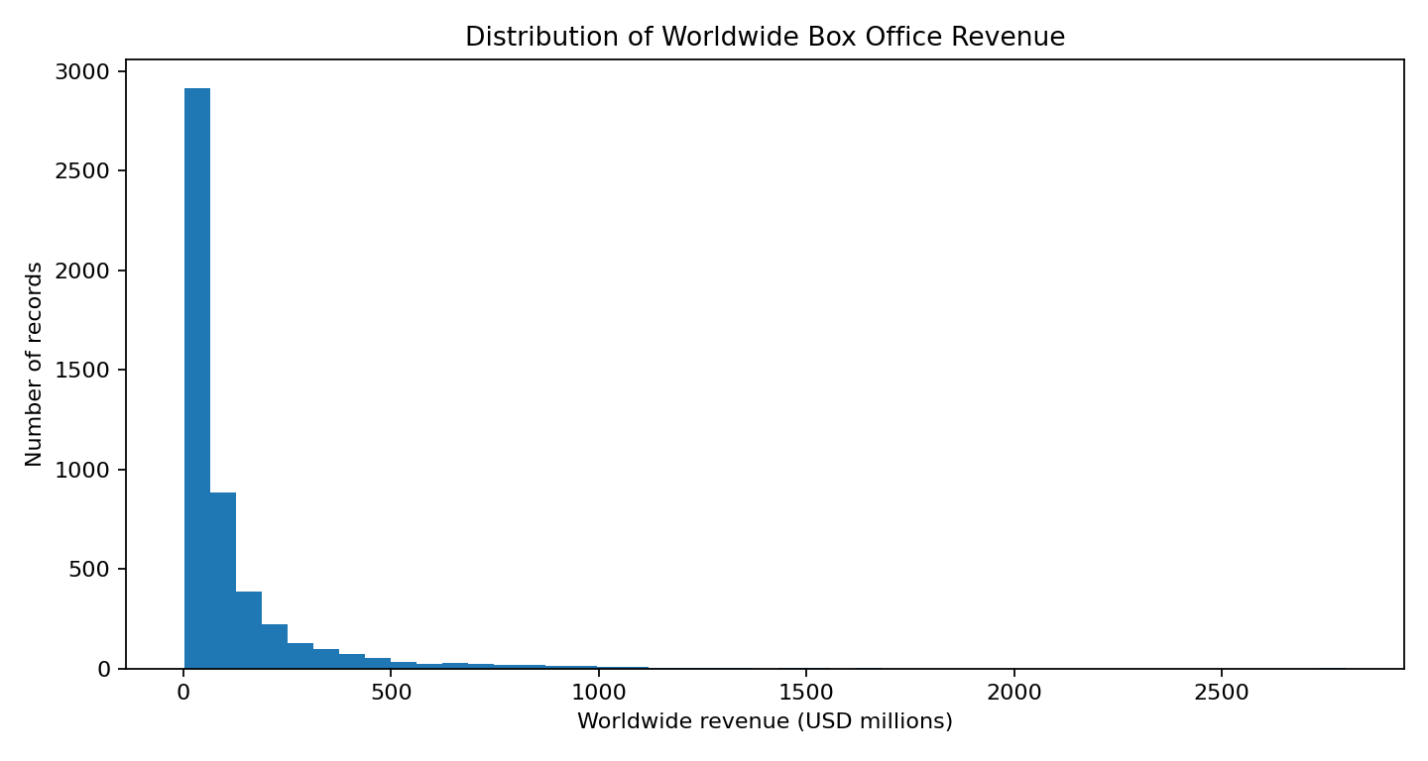
Implication: use medians and percentiles alongside means. For regression, a log1p transform of revenue can reduce the influence of extremely large values, although evaluation metrics should be converted back to the original currency scale.

7. Year-wise Trends
Because each year contains exactly 200 records, annual total differences are not caused by different row counts in this file. The highest summed worldwide revenue among these records is in {high_year} ($35.43 billion); the lowest is in 2020 ($7.86 billion).
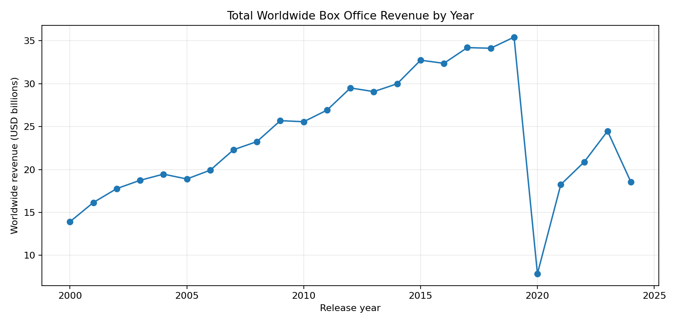
The pattern should be interpreted cautiously. The 2020 drop is visible in this dataset, but the dataset's selection method and release coverage should be checked before drawing broad industry-wide conclusions. Annual sums describe the records present in this file, not necessarily all films released in each year.

8. Top-Grossing Movies
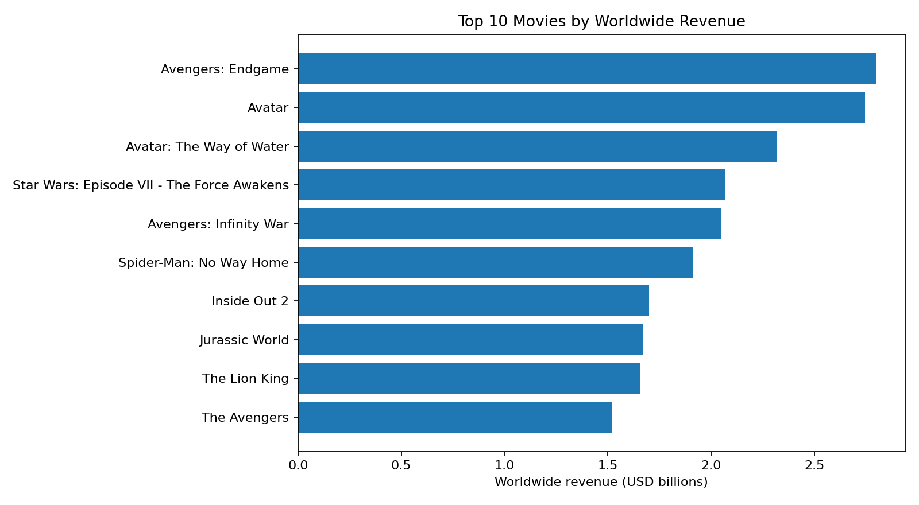
Movie | Year | Worldwide revenue | Rating
Avengers: Endgame | 2019 | $2,799,439,100 | 8.246/10
Avatar | 2009 | $2,743,577,587 | 7.583/10
Avatar: The Way of Water | 2022 | $2,320,250,281 | 7.616/10
Star Wars: Episode VII - The Force Awakens | 2015 | $2,068,223,624 | 7.271/10
Avengers: Infinity War | 2018 | $2,048,359,754 | 8.242/10
Spider-Man: No Way Home | 2021 | $1,910,982,770 | 8.0/10
Inside Out 2 | 2024 | $1,698,772,985 | 7.566/10
Jurassic World | 2015 | $1,670,400,637 | 6.7/10
The Lion King | 2019 | $1,656,943,394 | 7.116/10
The Avengers | 2012 | $1,518,812,988 | 7.724/10

9. Genre Analysis
Genres are multi-label fields: one film can be counted under several genres. Therefore, genre counts can sum to more than the number of distinct movies. The most common genres in the file are shown below.
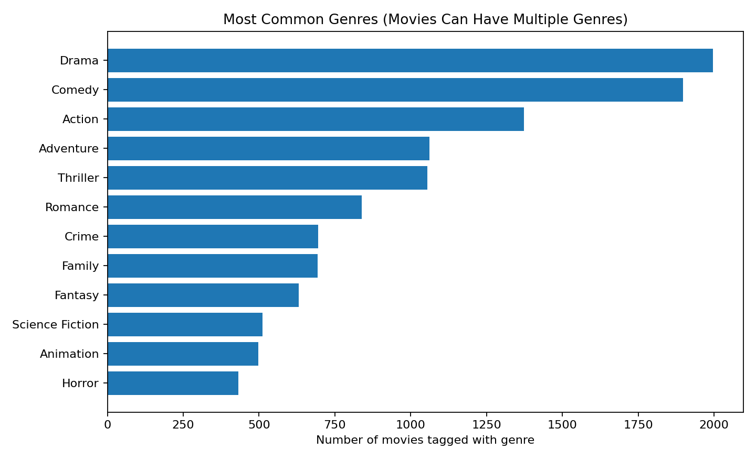
Genre | Movie count | Median worldwide revenue | Mean rating
Drama | 1,997 | $40,815,190 | 6.75
Comedy | 1,898 | $47,329,961 | 6.31
Action | 1,374 | $76,009,370 | 6.51
Adventure | 1,061 | $100,140,096 | 6.59
Thriller | 1,055 | $57,200,088 | 6.48
Romance | 839 | $42,029,930 | 6.47
Crime | 695 | $47,425,835 | 6.55
Family | 693 | $76,791,912 | 6.57
Fantasy | 631 | $79,558,422 | 6.57
Science Fiction | 512 | $109,627,213 | 6.54

10. Ratings, Votes, and Correlation
After parsing the rating text, the mean rating is 6.51/10 and the median is 6.60/10. Worldwide revenue and vote count have Pearson correlation r=0.723; worldwide revenue and rating have r=0.183. These are associations, not proof that votes or ratings cause revenue.
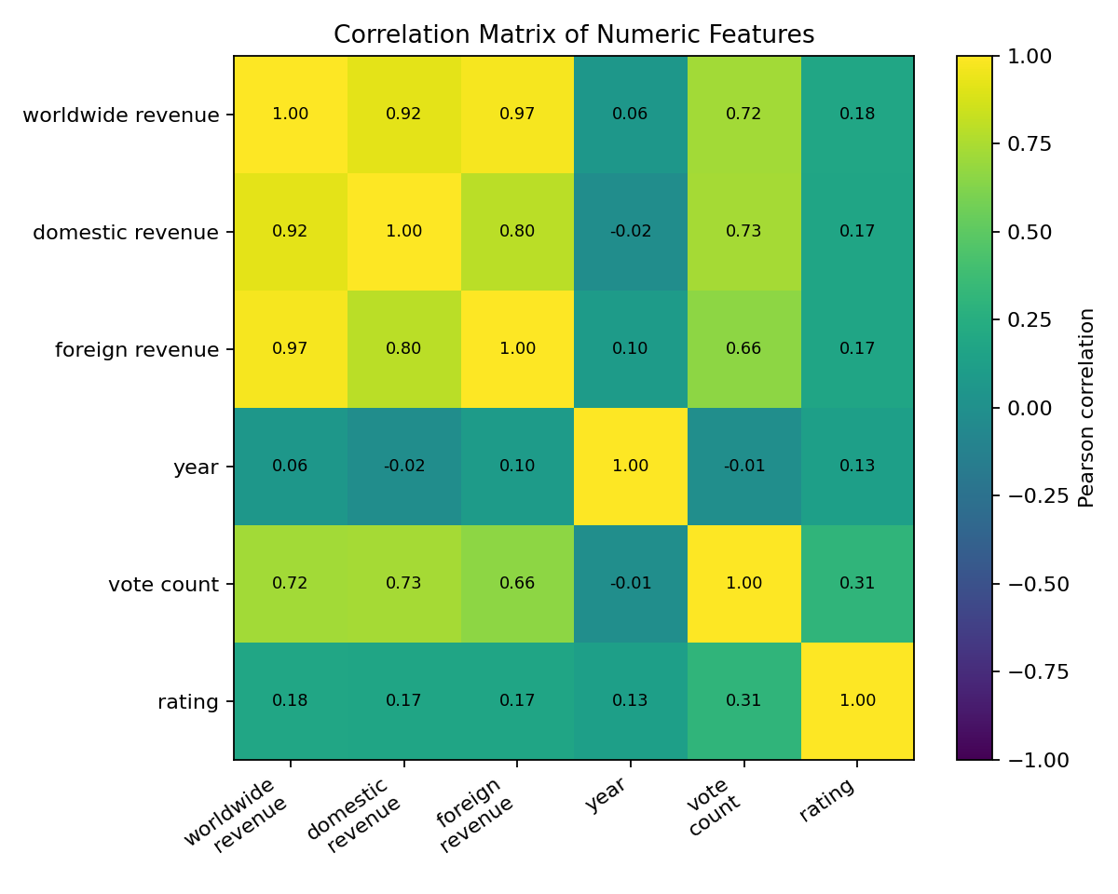
Worldwide revenue is mechanically related to domestic and foreign revenue (correlations are 0.915 and 0.972). Do not include either component as a feature when predicting worldwide revenue, because doing so creates target leakage. Derived percentage fields also encode components of the target and should be excluded from a clean predictive setup.

11. Language and Production Country
Most frequent original-language labels:
- en: 3,271 records (65.4%)
- ja: 369 records (7.4%)
- zh: 280 records (5.6%)
- fr: 203 records (4.1%)
- ko: 194 records (3.9%)
- Unknown: 170 records (3.4%)
- hi: 92 records (1.8%)
- de: 77 records (1.5%)
- es: 63 records (1.3%)
- cn: 61 records (1.2%)
Most frequent production-country combinations:
- United States of America: 1,964 records
- Japan: 357 records
- United Kingdom, United States of America: 217 records
- Unknown: 200 records
- South Korea: 180 records
- China: 172 records
- France: 124 records
- India: 102 records
- Canada, United States of America: 98 records
- Germany, United States of America: 89 records
Production_Countries may contain multiple countries in one string. Treating the whole string as one category is simple, but it creates many combination-specific categories. A future improvement is to split country lists into multi-label features or derive a consistent primary-country field.

12. Implications for DSA Components
- KMP and Rabin–Karp: search the title field after normalizing case and whitespace.
- Edit Distance: use title similarity for typo correction; for large datasets, shortlist candidates first to reduce work.
- Suffix Array: the current educational implementation sorts suffixes for each title at query time. For efficiency, build an index once or use a proper text-search structure.
- Graph/BFS/DFS: genre-based edges indicate shared genre, not actor/director relationships. The graph is a proxy for similarity, not a social or cast network.
- Ford–Fulkerson and Edmonds–Karp: current code demonstrates max flow on a separate example capacity matrix; a movie-specific network interpretation would need a clearly defined graph and capacity meaning.
- Greedy recommendation and randomized sampling: these are baselines; evaluate recommendation relevance before claiming quality improvements.

13. Implications for Revenue Prediction
The current dataset supports a retrospective model using Year, parsed Rating, Vote_Count, Genres, Original_Language, and Production_Countries. The proposed Elastic Net pipeline imputes missing values, standardizes numeric features, one-hot encodes categorical features, and models log1p(worldwide revenue).
Important limitations: ratings and vote counts may be observed after a movie's release; this makes the current setup unsuitable as a strictly pre-release forecast. The dataset lacks budget, runtime, cast popularity, director popularity, marketing spend, and release strategy. Add those features from a reliable source if the intended use is forecasting before release.
Recommended evaluation: keep a held-out test set; report MAE and RMSE in the original revenue scale and R²; compare against a baseline such as predicting the training-set median or mean. Because the data is time-indexed, also consider a temporal split (train on earlier years, test on later years) to better mimic future predictions.

14. Limitations and Risks
- The data selection method is not documented here; exactly 200 records per year suggests a fixed-size selection, so results may not represent the full film industry.
- Revenue values are assumed to be in US dollars based on the source column labels; confirm the source and currency definition.
- The dataset does not provide budget or profit, so revenue must not be described as profit.
- The Rating field is stored as text and has missing values; parsing should be checked for unusual values.
- Repeated movie titles exist, although there are no exact duplicate rows; titles alone are not always unique identifiers.
- Correlations do not establish causality and can be affected by blockbuster outliers and selection bias.
- A random train/test split may overestimate performance for future-year use; temporal validation is recommended.

15. Recommendations and Next Steps
- Confirm the dataset's source, selection criteria, revenue currency, and whether records represent all releases or a top-ranked subset.
- Standardize titles, normalize genre labels, parse ratings, and document every missing-value treatment.
- Validate that worldwide revenue is consistent with domestic plus foreign revenue and flag anomalies.
- Use a time-based train/test split for realistic future-year prediction.
- Avoid target leakage from domestic revenue, foreign revenue, percentage splits, or rank.
- Add production budget, runtime, cast/director metadata, and pre-release signals if available from a trustworthy source.
- Evaluate the recommender with explicit measures such as Precision@K or NDCG if relevance labels or user feedback can be collected.
- For scalable title search, precompute indexes instead of rebuilding suffix arrays for every query.
- Connect the flow algorithms to a clearly defined movie assignment/recommendation use case before presenting them as an operational component.

16. Conclusion
The EDA of 5,000 movie records from 2000 to 2024 identifies a highly skewed worldwide-revenue distribution, substantial blockbuster outliers, missing metadata, multi-label genres, and strong mechanical relationships between worldwide revenue and its domestic/foreign components. These findings inform data cleaning, visual analytics, graph construction, recommendation logic, and a more defensible Elastic Net model. The most important next step is to document dataset provenance and use leakage-aware, preferably time-based, evaluation before making claims about predictive performance.

Appendix A. Suggested EDA Workflow
Load data → inspect dimensions and schema → parse numeric fields → assess missing values and duplicates → summarize revenue distributions → analyze year, genre, rating, vote, language and country patterns → inspect correlations and leakage risks → prepare model features → evaluate model → document limitations.

